Module 1: Exploratory Data Analysis for Chatbot Queries
Project Title: AI-based Employee Chatbot with Document Analysis for Public Sector Organization
Project Overview:
This project involves the development of a chatbot using deep learning and NLP techniques tailored for employees in a large public sector organization. The chatbot is expected to accurately address queries related to HR policies, IT support, organizational events, and more.
Key functionalities include:
- Understanding diverse employee queries using NLP
- Handling parallel user queries (at least 5 users simultaneously)
- Filtering inappropriate language
- Document processing (summarization & keyword extraction)
- Email-based Two-Factor Authentication (2FA)

Exploratory Data Analysis (EDA)
Notebook Used: chatboat_EDA(1).ipynb
Tool Used: Python (Pandas, Matplotlib, Seaborn, WordCloud, etc.)
The initial step in chatbot development involved a thorough exploratory analysis of the query dataset to understand the pattern of questions, keyword distribution, and potential response categories. This analysis forms the foundation for model training and optimization.

Dataset Description
- Format: JSON
- Fields: Intent, Patterns (various user queries), and Responses
- Purpose: Used to train the chatbot to match patterns to intents and generate appropriate responses.
Key EDA Insights
- Intent Distribution:
  - Visualized the frequency of different intents to understand the most common query categories.
  - Example: High frequency for intents like "leave_policy", "it_support", "salary_queries", indicating areas to prioritize in response accuracy.
- Word Cloud Analysis:
  - Generated word clouds to identify frequent keywords in user patterns.
  - Common terms: salary, holiday, training, support, project, etc.
- Token Count & Intent Length Distribution:
  - Analyzed the length of patterns (in terms of tokens) to optimize input padding for model training.
  - Intent lengths are mostly within a 5–10 word range, suitable for LSTM/BERT input dimensions.
- Intent Frequency Histogram:
  - A histogram showing how many samples each intent contains, ensuring dataset balance for training.
  - Helped identify underrepresented intents for synthetic pattern augmentation.
- Unique Intents:
  - Counted a total of X unique intents (e.g., leave_policy, project_status, holiday_list, etc.).

Tools and Libraries Used
- Pandas: For structured data manipulation.
- Matplotlib & Seaborn: For intent distribution plots and histograms.
- WordCloud: For visualizing frequently used keywords.
- NLTK & Regex: For text preprocessing and token analysis.

Outcome of Module 1
- Clear understanding of data distribution across intents.
- Identified areas needing more data to ensure balanced model training.
- Insights from EDA used to structure better intent classification and response generation in subsequent modules.
- Built the base for implementing the document summarization, language filtering, and scalable user query handling in future stages.

Illustrative Visuals
Fig 1: Bar chart showing the frequency of each intent
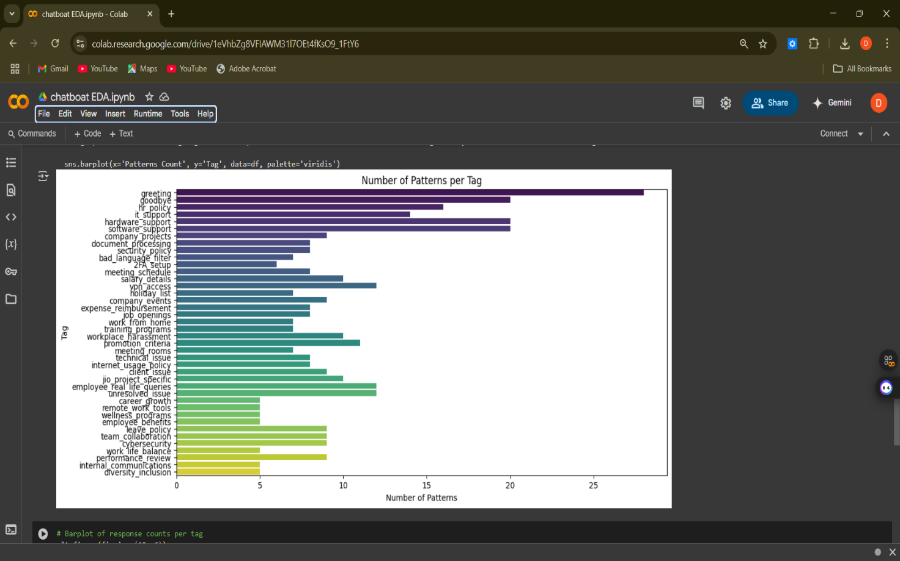

Fig 2: Histogram showing pattern token lengths across dataset
